Part 1
Question 1. Main entities và key attributes
- quan hệ N–N: tạo 1 bảng phụ, lấy 2 khóa chính của 2 bảng thành 2 khóa ngoại trong bảng phụ đó
- quan hệ 1-N: Lấy khóa chính của bảng 1, làm khóa ngoại của bảng nhiều
Based on the problem statement, the main entities and their logical key attributes are:
User
user_id (PK)
name
email
phone
address
password
Restaurant
restaurant_id (PK)
name
address
phone
Dish
dish_id (PK)
name
price
description
restaurant_id (FK)
Order
order_id (PK)
order_date
status
total_amount
user_id (FK)
restaurant_id (FK)
OrderItem
order_item_id (PK)
order_id (FK)
dish_id (FK)
quantity
price
Question 2: Conceptual ERD
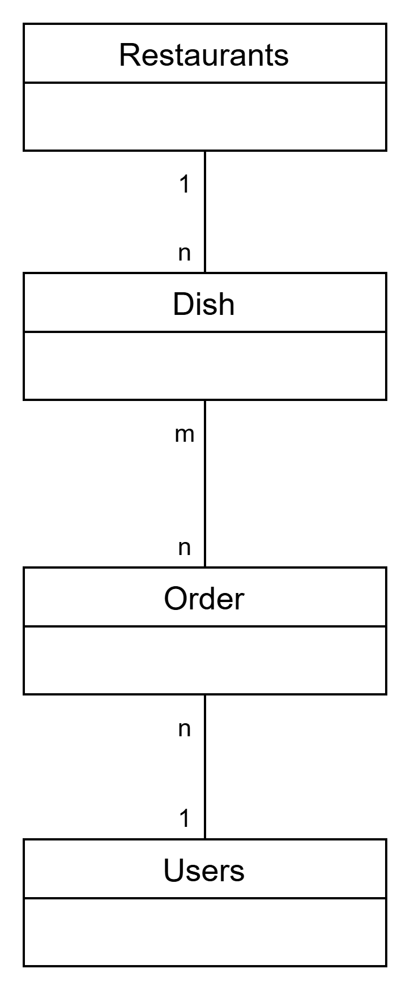
Question 3: Logical ERD
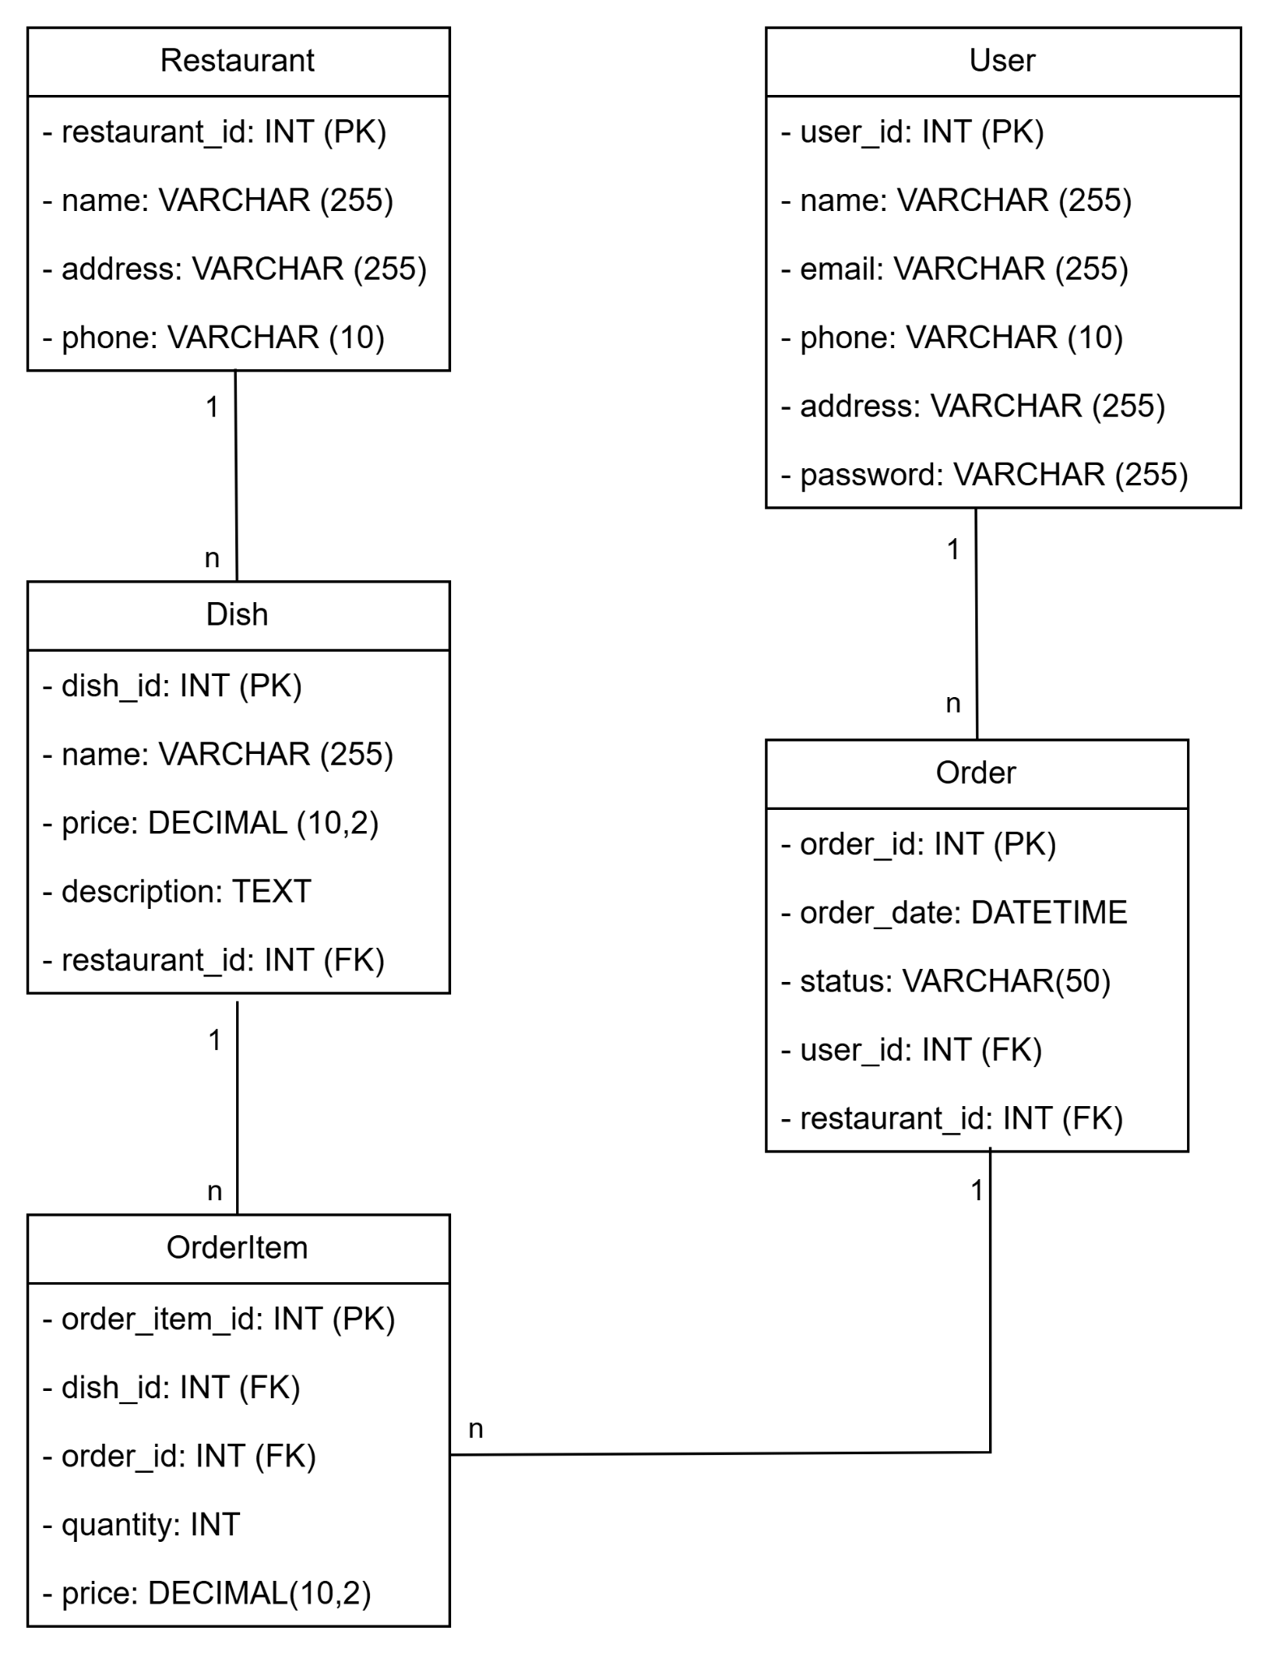

Question 4:
Main state of the Order entity:
+ Pending: The order has been submitted by the user but is awaiting confirmation from the restaurant.
+ Confirmed: The restaurant has accepted the order and is preparing it.
+ In Preparation: The order is actively being cooked/prepared.
+ Ready for Delivery/Pickup: The order is complete and waiting for a driver or user pickup.
+ In Transit: The order is out for delivery.
+ Completed: The order has been successfully delivered and received by the user.
+ Cancelled: The order was cancelled (either by the user before confirmation or rejected by the restaurant).

State diagram for Dish:
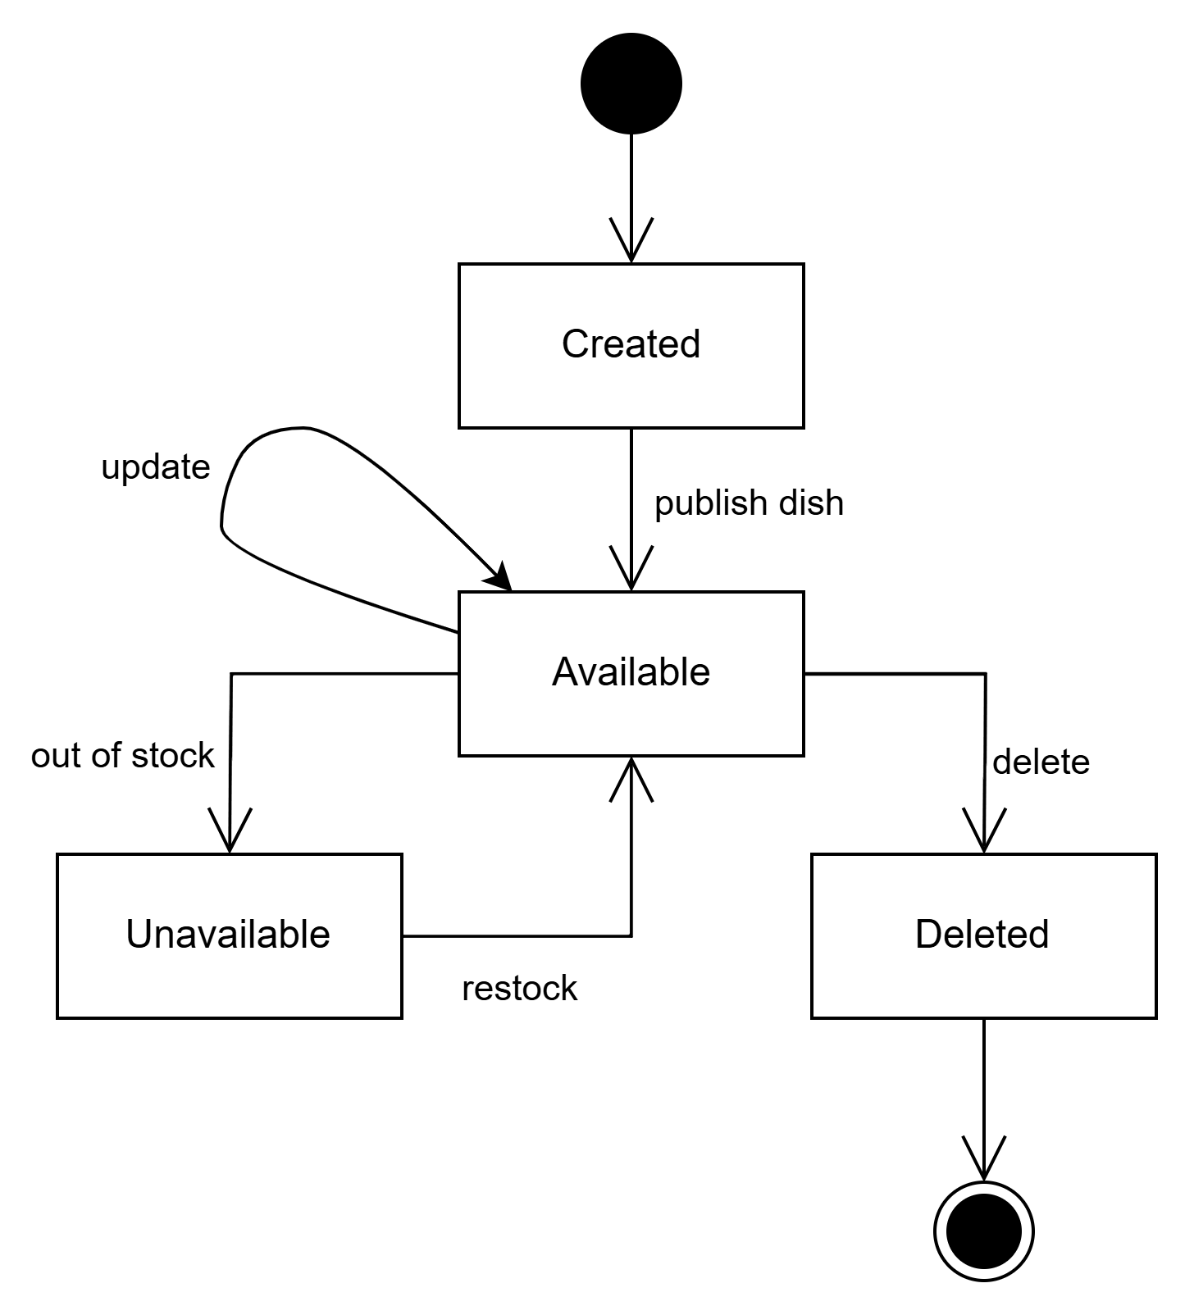

Part 2
Question 1: Classes/Tables for "Place Order" Function
1. Client-side
Component
- Cart: CartItem contains the information of dishes selected by the user before placing an order.
- Fields: dishID, name, quantity, unitPrice
- The cart stores all selected items that will be sent to the server when the user clicks Place Order.
- CheckoutForm: The checkout form collects the order information from the user.
- Fields include: user details, delivery address, payment method
- After the user confirms the order, this data will be sent to the server through a REST API request.
- Auth: Authentication is handled on the client side using JWT (JSON Web Token).
- The login token (JWT) is stored on the client.
- The token is sent in the HTTP request header when placing an order.
- Example: Authorization: Bearer <JWT token>. This token allows the server to identify and authenticate the user.
2. Server-side
- Controller (OrderController)
- Responsibilities:
Receive the request: POST /api/orders
Check authentication and authorization of the user.
Ensure the user is allowed to place an order.
Call the OrderService to process the order.
- The controller mainly handles the HTTP request and delegates the business logic to the service layer.
- Service (OrderService)
- The service layer contains the main business logic of the "place order" function.
- Responsibilities:
Verify that the restaurant exists.
Check dish availability and quantity.
Validate the order items.
Compute the total_amount of the order.
Create a new Order entity.
Create associated OrderItem entities.
Set the initial order status (e.g., Pending).
- Repository
- Repositories are responsible for database operations.
- Repositories used in this function:
OrderRepository
DishRepository
RestaurantRepository
UserRepository
- Responsibilities: Perform CRUD operations (Create, Read, Update, Delete).
- Example operations: saveOrder(), findDishById(), getRestaurant()
3. Database Tables Used
- The following tables are used when processing the place order function.
- Database tables used : Order , Dish , Restaurant , User , OrderItem
Question 2:
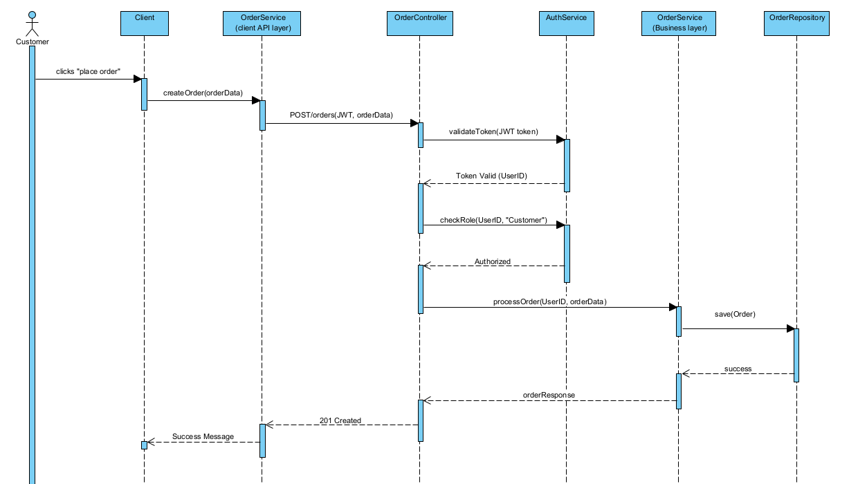
Part 3:
Question 1: Pattern Identification
Pattern Name:Decorator Pattern
Pattern Family:Structural
Reasoning: The code allows for adding new responsibilities to an object dynamically. It does this by wrapping the original object in decorator objects that extend its behavior without modifying its structure. This is the classic definition of the Decorator pattern, which uses composition to extend functionality rather than inheritance.
Question 2:
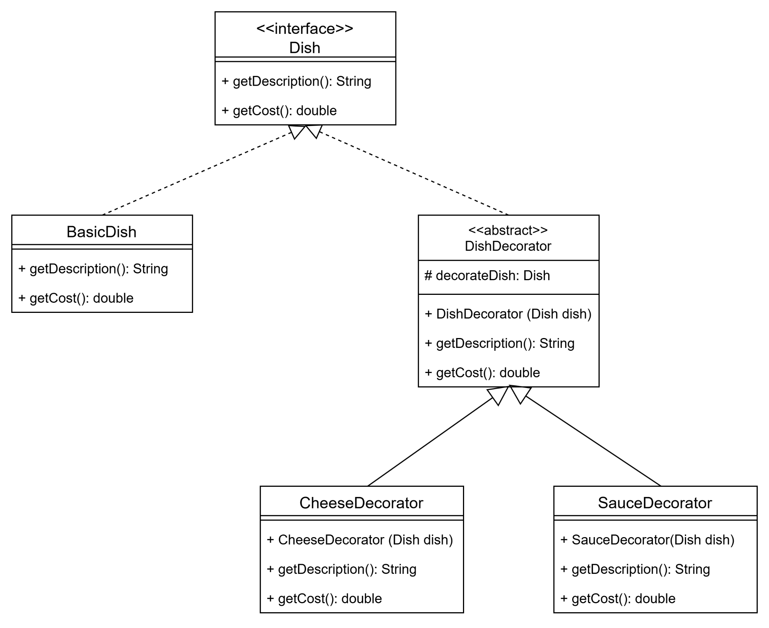

Question 3:
A practical situation is dynamically adding features to a product in a system. For example, in a coffee ordering application, a basic coffee can be decorated with additional options such as milk, sugar, or whipped cream. Each extra feature wraps the original object without modifying its core structure.

